http://www.npr.org/2014/08/21/342184458/breaking-british-burn-washington-2-centuries-ago
Directions: Follow the link above to hear the audio. Read below for an introduction into the audio.

BREAKING: British Burn Washington ... 2 Centuries Ago
by NPR STAFF
August 21, 2014 4:01 PM ET

Listen to the Story
All Things Considered
12 min 47 sec
- Playlist
- Download
- Transcript
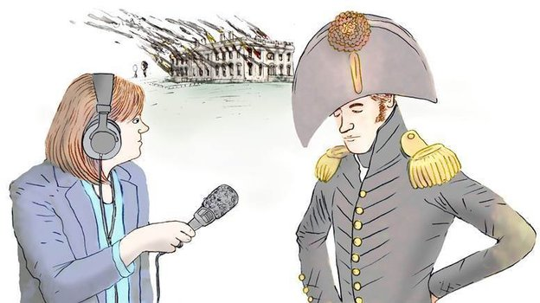
Tamara Keith on the scene in 1814. Sort of.
Leif Parsons for NPR
Two hundred years ago this week, during the War of 1812, invading British troops destroyed two of the nation's most important buildings — the White House and the Capitol. The war had started over issues of tariffs and the taking of American sailors on the high seas; by the summer of 1814, British fighters were in middle of a campaign burning and looting along the coast.
Unfortunately, there was no recorded sound from that time, so for help in our storytelling we imagined how NPR might have covered the burning of Washington, D.C., had we been on the scene two centuries ago. This is definitely one of the stories that you'll want to listen to — click the play button above to hear it.
This re-enactment of the siege is based on Steve Vogel's bookThrough the Perilous Fight: From the Burning of Washington to the Star-Spangled Banner, the Six Weeks That Saved the Nation.
Our cast of characters:
- "War Department" Correspondent Tom Bowman, embedded with the invading British forces
- "President's House" Correspondent Tamara Keith, reporting from the White House under siege
- Congressional Correspondent Ailsa Chang, reporting from the soon-to-be burned U.S. Capitol
- WAMU's Armando Trull, embedded with the District of Columbia militia
- E.J. Dionne and David Brooks with their regular weekly analysis of the 1814 news

