Indus Civilization

Early History
Some of the oldest human remains in South Asia date back to around 75,000 years ago. These early humans made tools and lived a nomadic hunter/gatherer life. Artifacts indicate that around 5000 BCE, farming developed in South Asia. Slowly, people began to live in permanent places and villages slowly developed—eventually these villages turned into cities and created one of the earliest human civilizations in the world. This civilization is known by many names: Ancient India, Indus Valley, and Harappan Civilization. Historians and archeologists believe the Indus Valley Civilization began around 3000 BCE. There is evidence of trade between Ancient India and Mesopotamia as early as 3200 BCE. This an other evidence suggests Ancient India relied on trade in a larger way than other early civilizations.
Ancient India
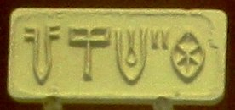
Ancient India is often called the Harappan Civilization because one of the ancient cities was called Harappa. Harappa was just one of 1500 cities in the Indus River Valley. Another well-known city is called Mohenjo-Daro. Historians estimate Ancient India to be the biggest of all four early civilizations. This civilization was not discovered until the 1920’s CE, and much of this civilization remains a mystery. One reason the Indus Valley civilization is so mysterious is because historians have not been able to translate their complicated written language called Indus Script. There are thousands of artifacts with 400-600 different written symbols. Most of these symbols were pressed into soft clay with seals. A seal is similar to a stamp that makes an impression in the soft clay. Seals are sometimes in a cylinder shape so they can be rolled on the clay. Indus Script symbols have been discovered in Mesopotamia, which suggests they maintained a regular trade.

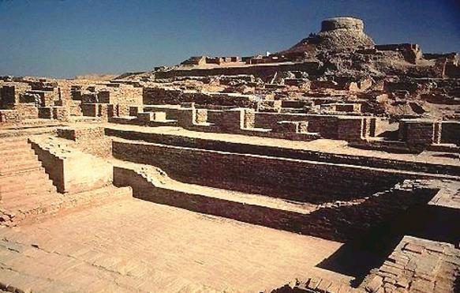
The archeologist have found the remains of cities to be incredibly well planned out. Historians estimate that each major city could support as many as 80,000 people, so Ancient India was by far the largest early civilization. The buildings were made from mud-bricks that had been fired in a kiln to make it harder. A kiln is a hot oven or furnace to bake clay pottery. City planners started by digging water wells and water drainage systems with main roads and small roads laid out in a square grid. Finally homes were built along the roads, sometimes with multiple stories. It appears that most urban homes had water drain systems in the their home--a technology that wouldn't be matched in history for over 3000 years. However, most people didn't live in the urban areas. Most people lived in farming villages in rural areas.

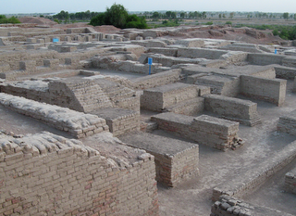
Farmers domesticated several plants including melons, wheat, peas, dates, sesame seeds, and cotton, as well as many animals. Archeologists have discovered what food the Ancient Indian people ate by examining the teeth of skeletons and food storage areas. Another example of how well planned the Indus Valley civilization was is their grain storage building. Some historians believe they have discovered a massive granary nearly 200 feet long to store and dry wheat. However, there is no evidence of grain in this building, so once again, historians are uncertain about the mysterious Indus Valley civilization.
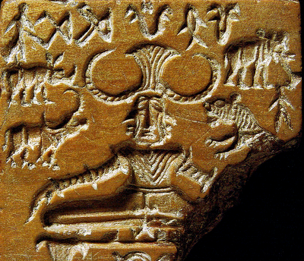
Ancient India was different from the Egyptians and Mesopotamians in several ways. One way they are different is that there appear to be very few large structures in Ancient India. One of the largest structures that has been discovered is called the Great Bath. Basically its a public pool that is over 40 feet long, 20 feet wide, and nearly 10 feet deep. If large temples or palaces once existed they are gone today. This leads to a curious question--did Ancient India have kings or high ranked religious leaders? What did the social pyramid look like? The remains of the civilization suggests they were a very egalitarian society. Egalitarian means everyone in society was basically equal. Another difference is in military and weapons. There is very little evidence of weapons and military culture in the Indus Valley. Another difference is that astronomy seems to be less important in India than in other civilizations unless the text has been lost.

The Indus Valley religion is also mysterious because the language hasn't been translated. Historians believe they may have worshiped a Mother Goddess. They believe the Great Bath could have been used for some type of baptism. A small artifact has been found that some historians think may be a priest (right), but archeologists have yet to find a temple of any kind. Some of the Indus Script symbols are related to the images of the modern religion of Hinduism (left), but historians don't all agree about the symbols. The image to the left shows a three-faced person sitting in the lotus position. The lotus positions is a Yoga position of meditation where a person sits upright with their legs folded in their lap. Yoga is a spiritual practice of meditation, breathing, and body position used in many religions, especially Hinduism.

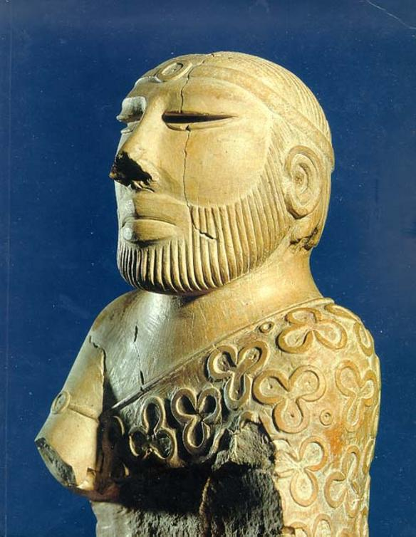
By 1500 BCE, the once vast and powerful civilization began to decline at some point it suddenly ended. Historians are uncertain why this area’s power declined. There are some theories that a great earthquake crumbled cities and changed the path of rivers, which caused them to move to a new location. Another theory claims the climate may have changed, which forced them to move. Yet another theory suggests invading armies destroyed some cities and forced most people to move. One thing we know for sure is that the civilization that once lived in this area ended and new people moved into this area.

