Mesopotamia's First Civilization--Sumer

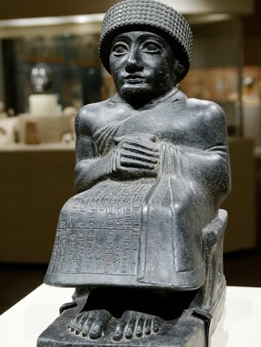
Around 3500 BCE, people were growing more food than they needed, which allowed the division of labor. People were living in multiple cities with governments and religions. A written language developed around 3300 BCE—civilization is official! The first civilization to develop was called Sumer in southern Mesopotamia. Sumer was a collection of city-states, most of them with thick defensive walls because the city-states were often at war with one another. Major cities included Eridu, Uruk, Ur, and Lagash. Uruk was one of the largest cities; at one time it may have had 80,000 people living in and around the city. This time period began a great human migration from the countryside into the city.

Mesopotamia invented new technology. They were the first to use the wheel. The wagon was a transportation revolution for farming and trade. They developed a number system based on 60--this explains why we have 60 seconds in minute and 60 minutes in an hour. They used a 12 month calendar with a 7 day week. Astronomers studied the stars an mapped the first set of constellations. Early writers wrote the earliest known literature called the Epic of Gilgamesh, which tells the tale of the struggle between man and the Gods. They also created architectural structures such as the dome, the column, and the arch. Architecture is the art of building structures (buildings of any kind). All that remains today of most Mesopotamian architecture are mounds of dirt and clay called a tell--broken mud-brick buildings in modern-day Iraq. This is why the architecture of Mesopotamia is hard to find today. The mud-bricks have eroded away, but archeologists have uncovered amazing artifacts under the ruble that tell the story of these ancient people. A tell is also a good place to look for graves. We have learned a great deal about Mesopotamia and other civilizations from exploring their burial grounds.

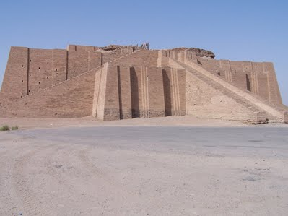
Sumer was not the only group to develop in Mesopotamia, but their culture influenced future civilizations. The government was organized around one king, the man dominated the household, and their religion believed in some kind of afterlife. Their culture had social classes—groups of people with similar backgrounds, wealth, and ways of living. Social classes were formed when people began doing different jobs. The jobs made them live in different ways, wear different cloths, and earn different amounts of wealth. All of these culture characteristics would be passed on.
In Sumer, the city became the center of trade, religious, and social life. The city layout reflected the rank of developing social classes. At the center of each town was a religious temple called a ziggurat. Palaces for the king's family surrounded the temple. Homes and shops for government workers, scribes, and craftsman surrounded the royal palaces. Smaller houses were usually found on the outsides of the city, but still in the large defensive walls that surrounded the city. Narrow alleys and small streets divided the houses.

The religion was slightly different in each city-state, but all of them were polytheistic. Polytheism is the belief in many Gods. They believed the Earth was a flat disc and the sky had holes that showed the light of heaven above. They believed their kings descended from the Gods. They buried their important people with their personal belongings and sometimes their servants. One grave had nearly 70 servants who were buried with their leader.
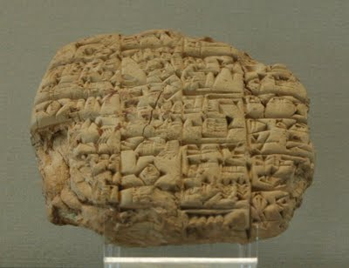
Over five thousand years ago, people living in Mesopotamia developed a form of writing to record different types of information. The earliest writing was based on pictures that represent words or phrases—these are called pictograms. Pictograms were used to communicate basic information about crops, taxes, and lending (loans). This type of writing required hundreds of symbols. Over several hundred years, the pictures developed into a type of writing we call cuneiform. Cuneiform was different because the symbols now stood for sounds, similar to our alphabet. At some point scribes began using a new wedge-shaped tool to press into the wet clay tablets. Paper had not been invented so they wrote on wet clay tablets. Scribes were the only people who knew how to read and write. Over thousands of years, Mesopotamian scribes recorded daily events, trade, astronomy, and literature on clay tablets. The first alphabet would develop around 1000 BCE by a different civilization along the Mediterranean called Phoenicia. All modern alphabets can be traced back to this extremely important development in writing.
The countryside farmers grew food for themselves and everyone in the city. In this dry region they depended on the regular flooding of the Tigris-Euphrates Rivers. They used careful irrigation to save water in pools and canals to keep for later use during dry times. Irrigation is a way to water fields without rain. Most of the farmers grew grain crops such as barley or wheat. These wild grasses produced grains that could be ground up to make flour for bread. Peas, garlic, onions, dates, and figs were also grown. The crops were brought to the temple to be stored or to market for trade or sale. Over the next several thousand years, Sumerian civilization influenced the surrounding area. New city-states rose to power in the region such as Akkad, Babylon and Assyria. Each of these cities grew into empires as they conquered the surrounding area and constantly fought each other.

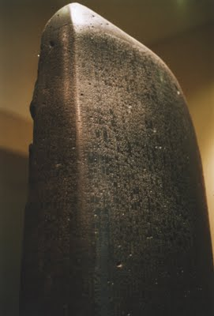
Babylonia
Babylonia came into power when King Hammurabi created an empire out of the former kingdoms of Sumer and Akkad. Babylonia gets its name from their capital city, Babylon. Babylon is probably the most famous city in Ancient Mesopotamia because of its regular mentions in Jewish and Christian religious writings.

Babylon became known for impressive architecture and its laws and government. A Babylonian king named Nebuchadnezzar II built the Hanging Gardens of Babylon. The Hanging Gardens of Babylon were one of the Seven Wonders of the Ancient World. Nebuchadnezzar II supposedly built these around 600 BC because his wife missed the forests and jungles of her home. The gardens didn’t actually hang—they were simply built on top of towers, platforms, and temples. The plants hung down the side and gave an appearance of “hanging” plants. Hammurabi is also known for creating a system of laws called the “Code of Hammurabi” that has had a lasting influence on legal thought. Only one example of the Code survives today on a seven foot, four inch tall basalt stone slab. The Code is considered an early form of what is now known as a constitution. There are 282 laws in the Code of Hammurabi. After Hammurabi, Babylon was conquered by the Assyrians and controlled for centuries until they finally recaptured and increased their empire in 627 BCE.

